Kevin Abrahams

Job Hunt Application

Python Project

10/13/21

I have created a Job Hunt Application which shows the user job information to help the user in their job search to find, view, and apply for jobs.

**A welcome message appears. The user is asked if this is their first time using this application. Since it is, job data is loaded from a default starter file called jobs.csv:**

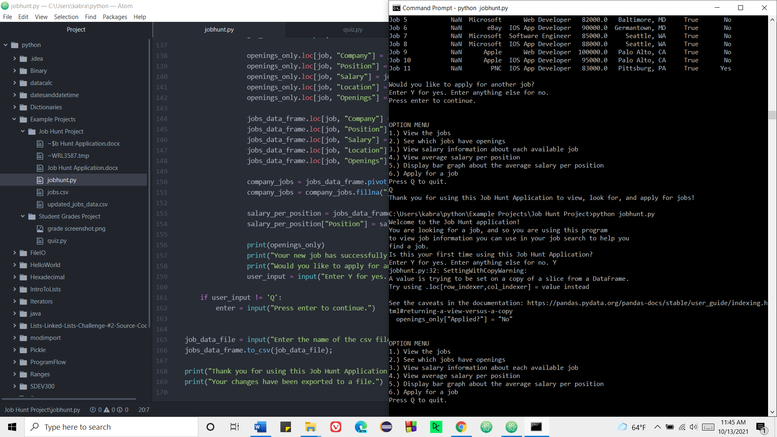

**User chooses option 1 to view the jobs:**

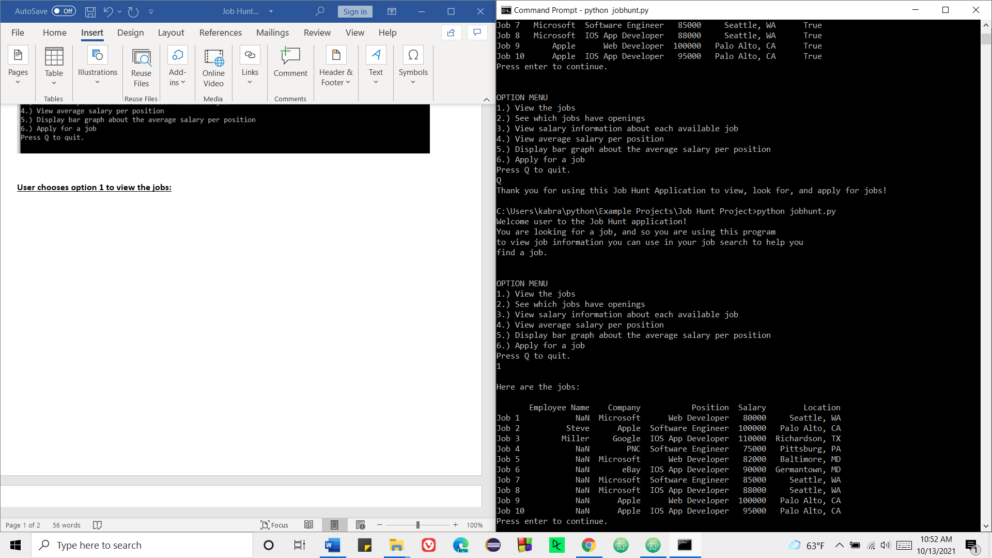

**User chooses option 2 to see which jobs have openings:**

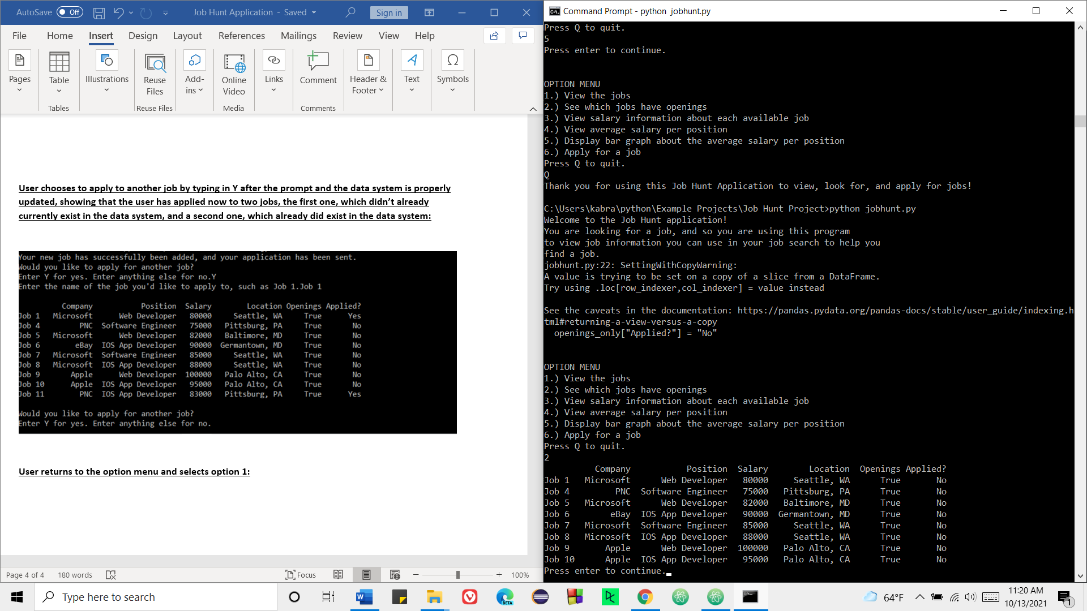

**User chooses option 3 to view salary information about each available job:**

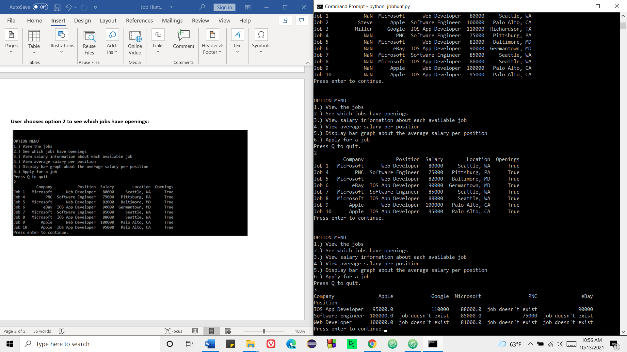

**User chooses option 4 to view average salary per position:**

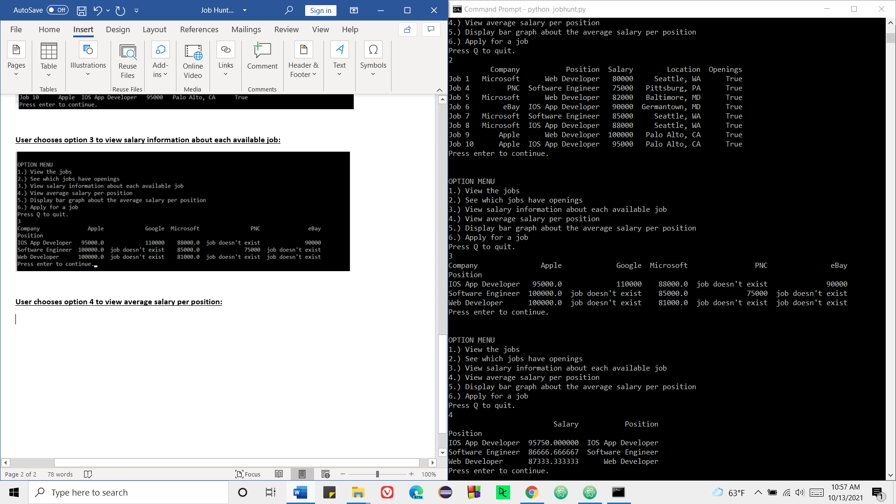

**User chooses option 5 to display a bar graph about the average salary per position:**

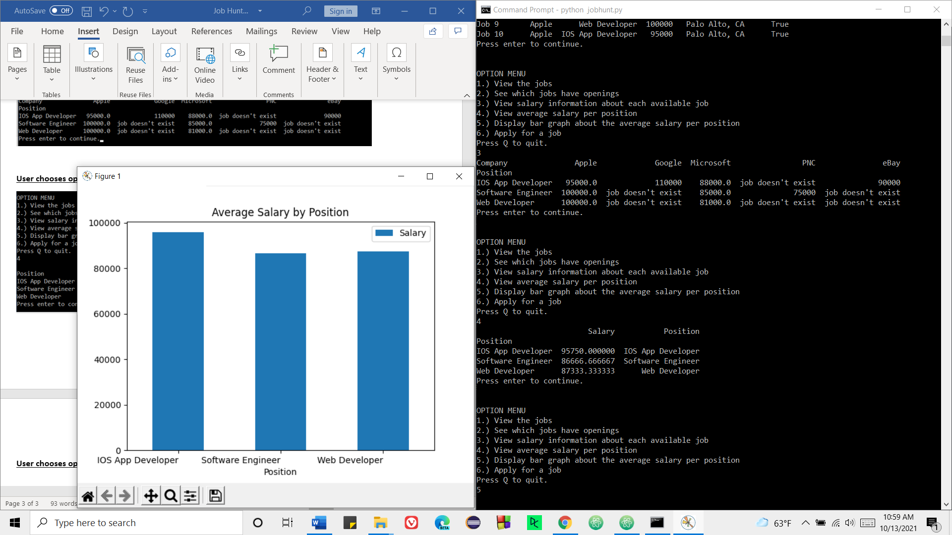

**User chooses option 6 to apply for a job but the job doesn’t exist so it is added to the data system:**

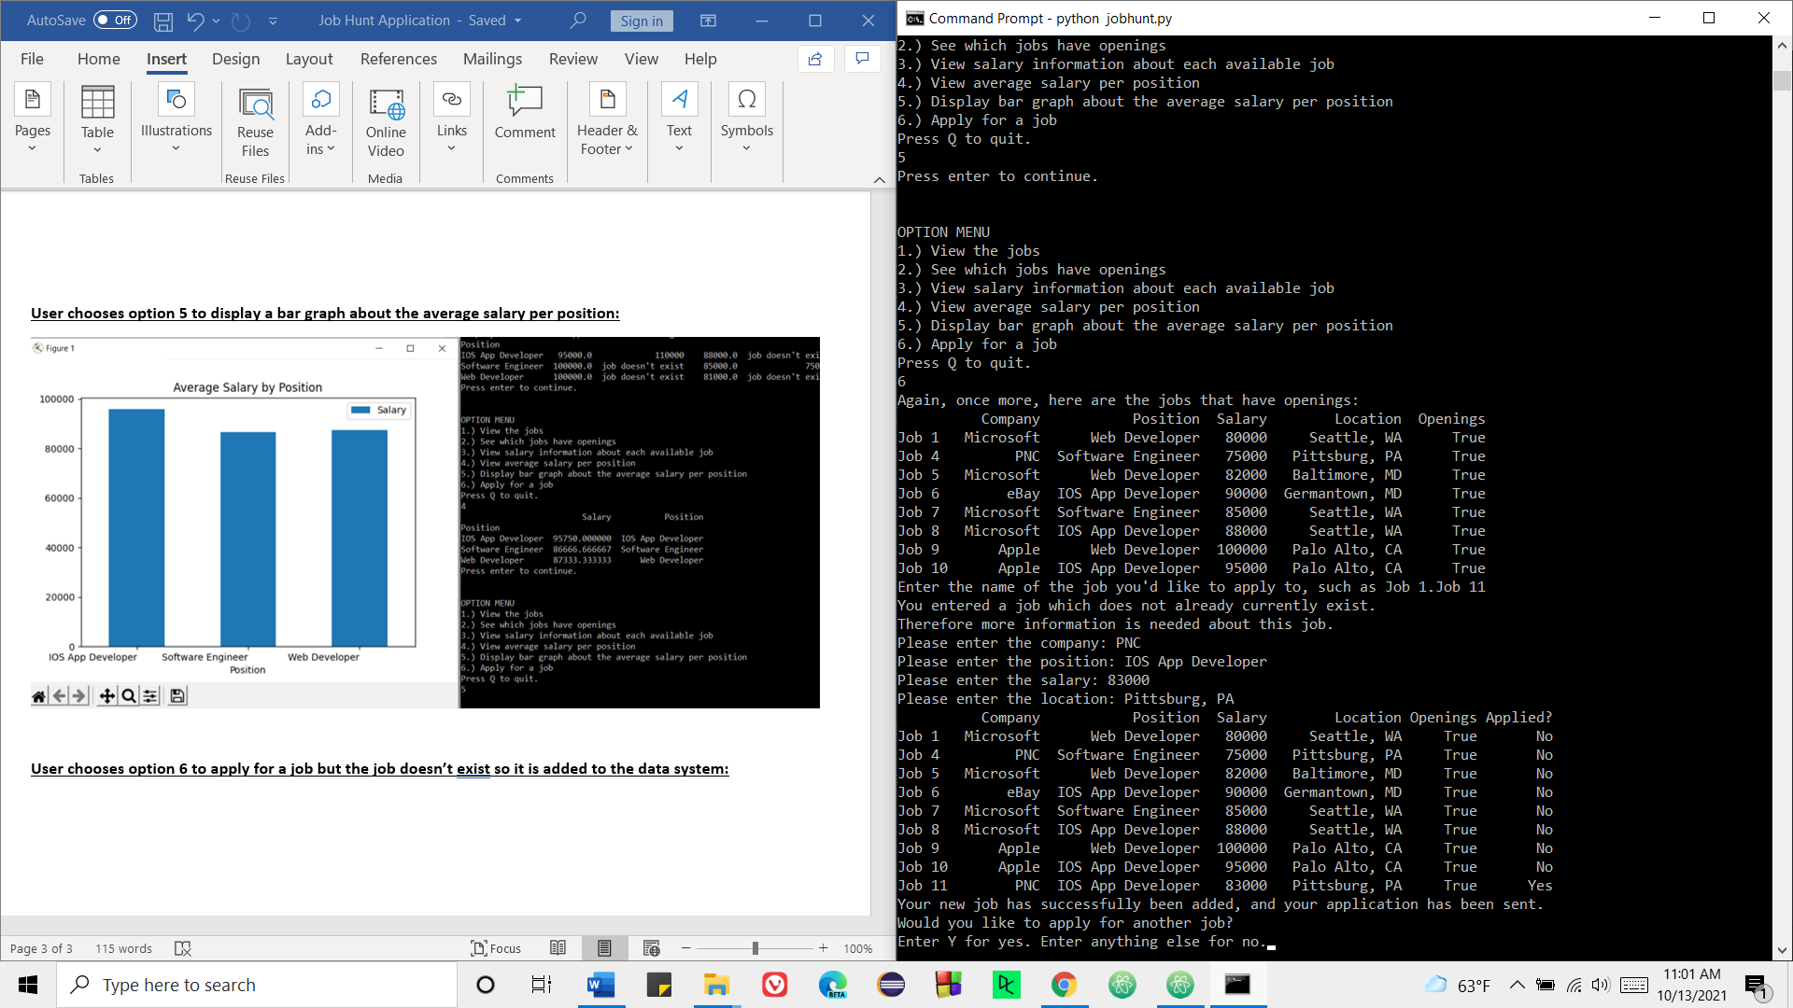

**User chooses to apply to another job by typing in Y after the prompt and the data system is properly updated, showing that the user has applied now to two jobs, the first one, which didn’t already currently exist in the data system, and a second one, which already did exist in the data system:**

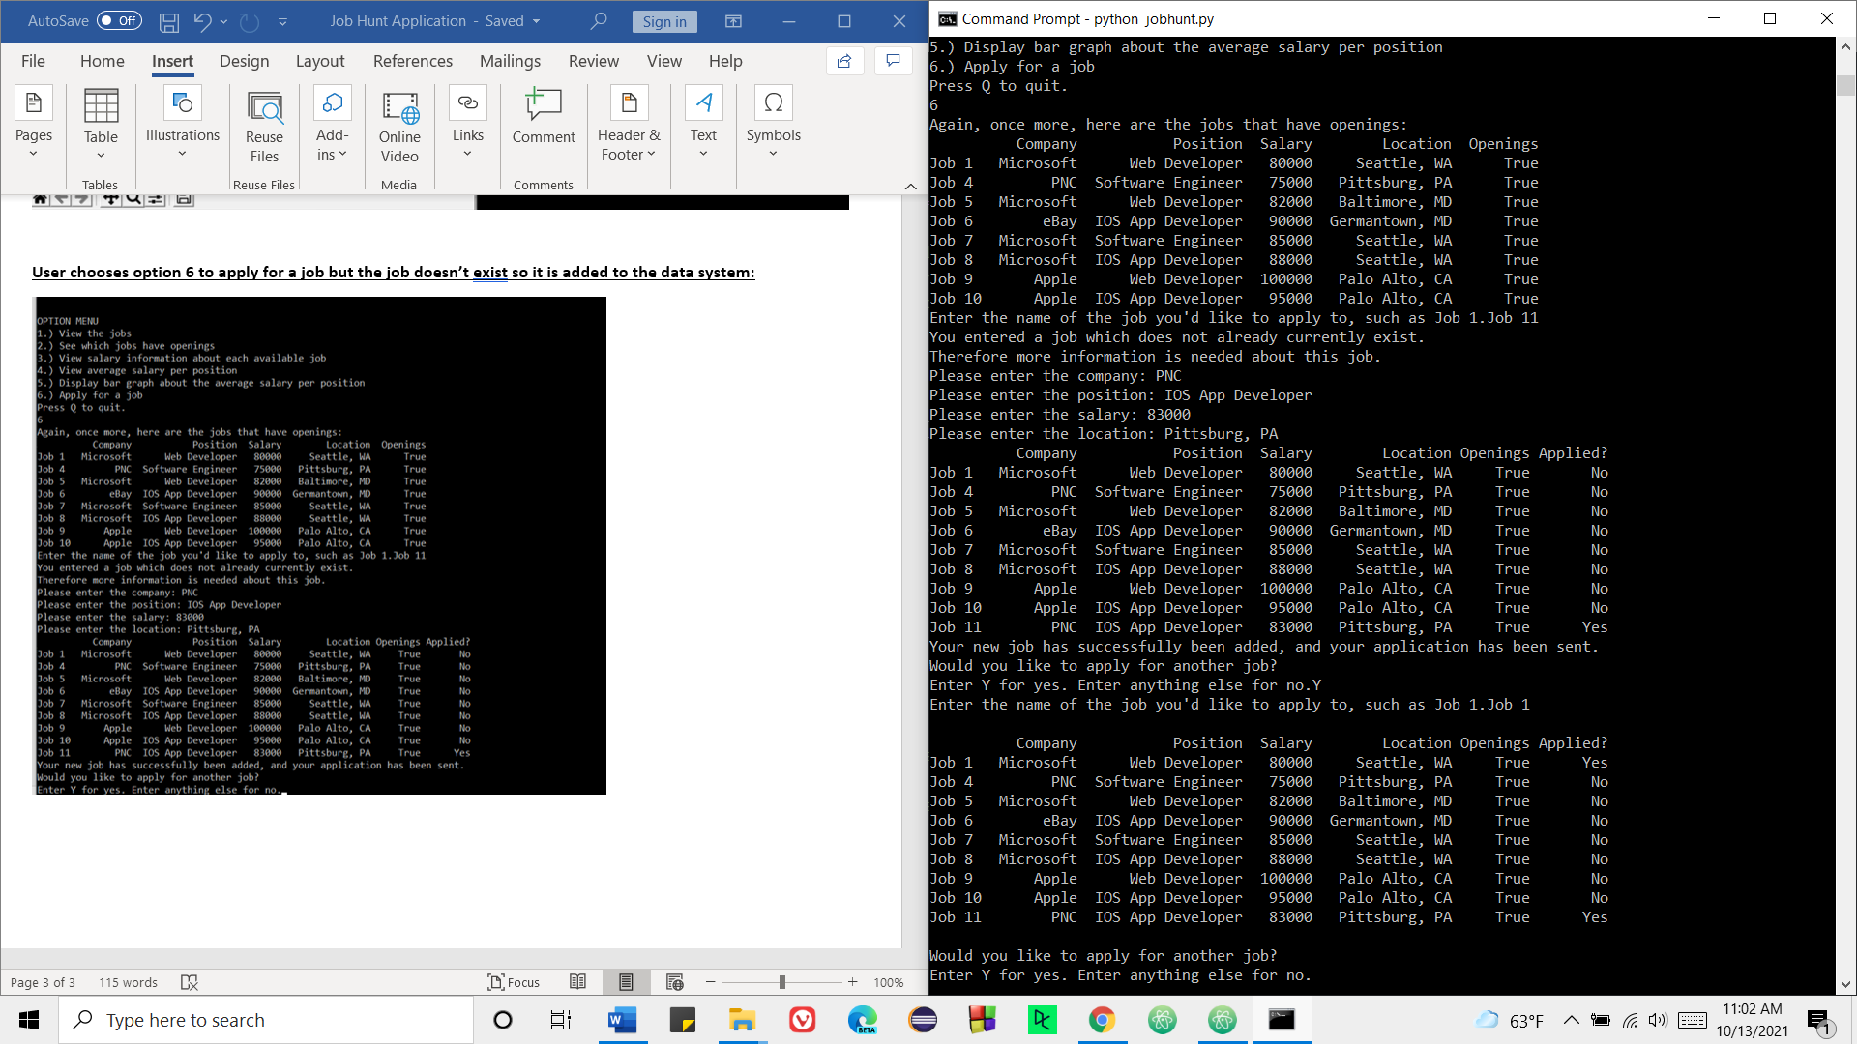

**User returns to the option menu and selects option 1:**

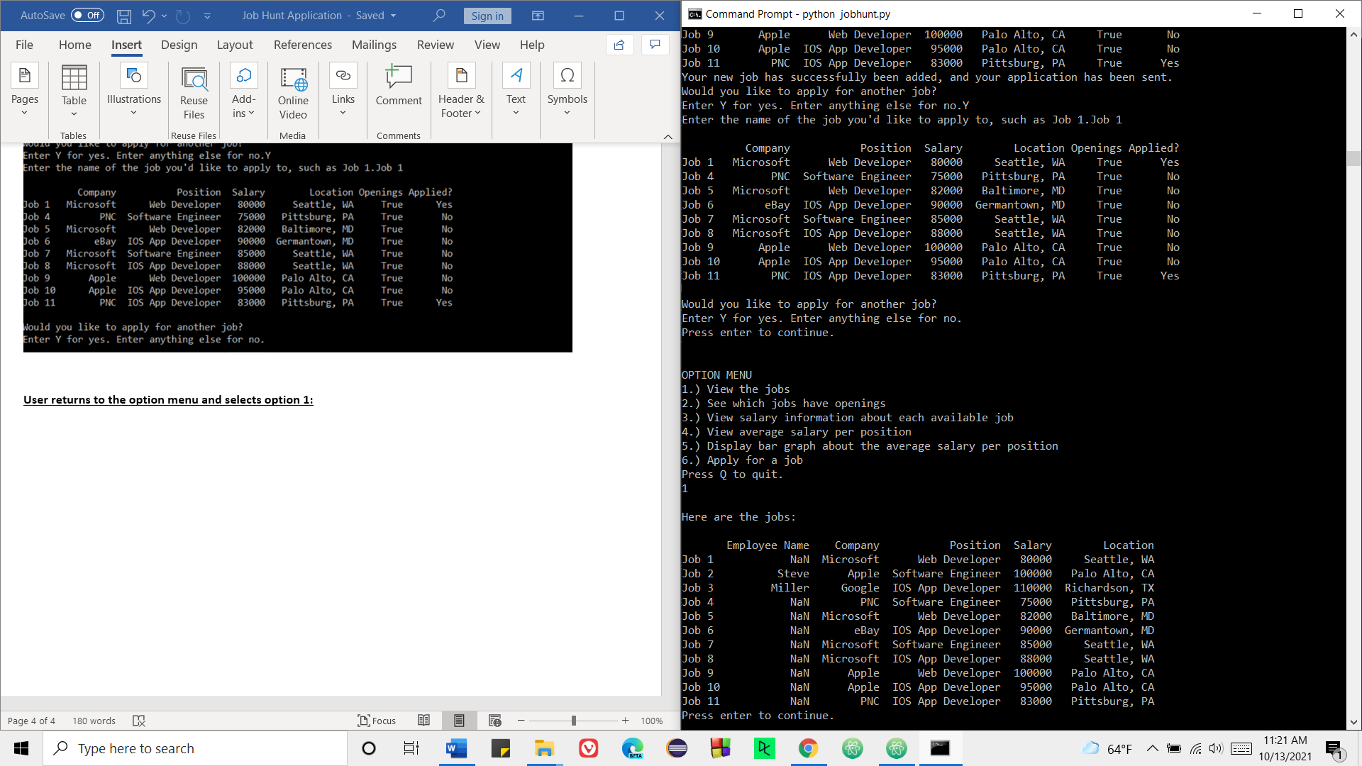

**User chooses option 2 again to see which jobs have openings. Notice how the job data has changed and been updated.**

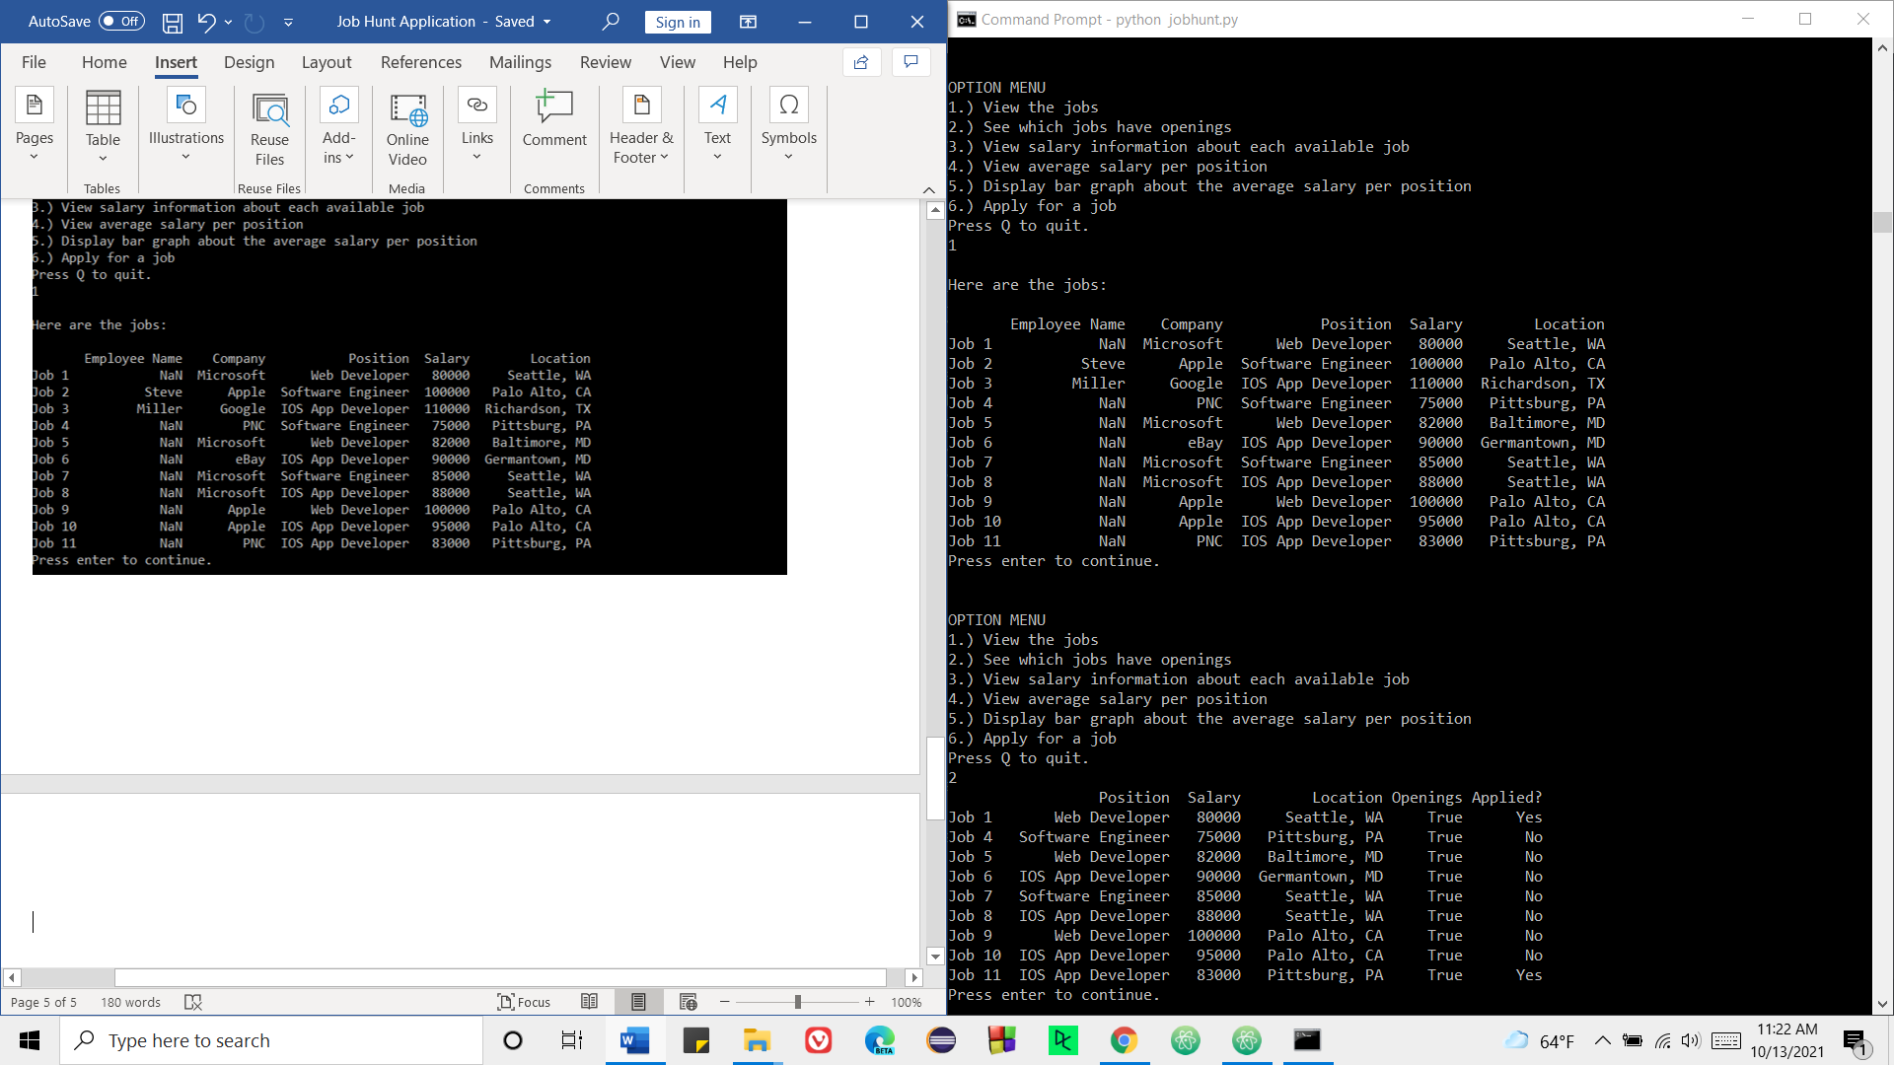

**User chooses option 3 again to view salary information about each available job. Notice how the PNC IOS App Developer position no longer says job doesn’t exist, but now says 83000, representing the salary for the position. This reflects the changes made when the user chose option 6 and applied to the new position.**

Before and after:

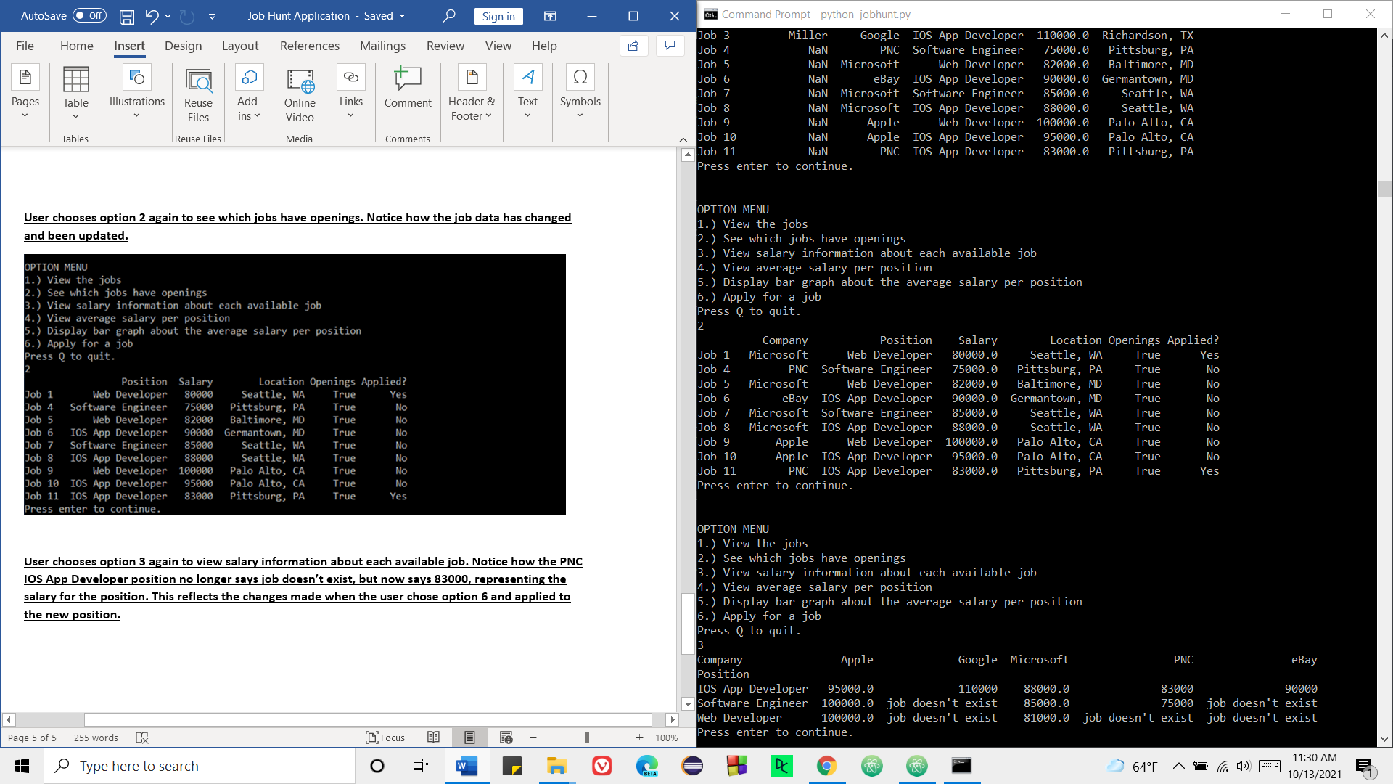

**User chooses option 4 to view average salary per position. Notice the slight decrease in the average salary for IOS App Developer (from 95750 to 93200):**

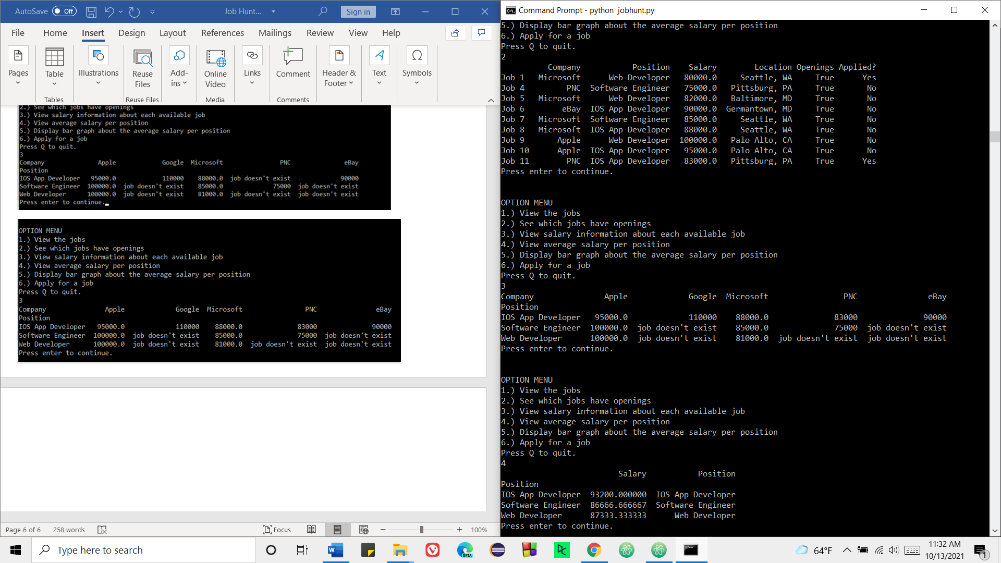

**User chooses option 5 to display bar graph again about the average salary per position:**

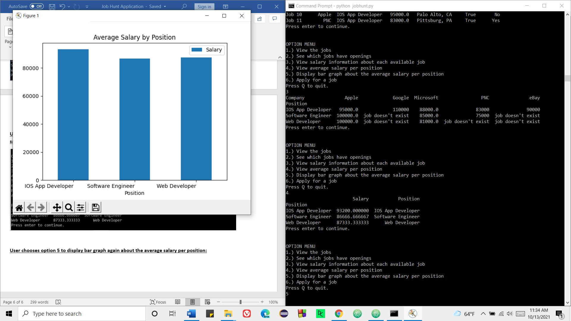

**User chooses option 6 to apply to another job, job 4 at PNC, which already exists:**

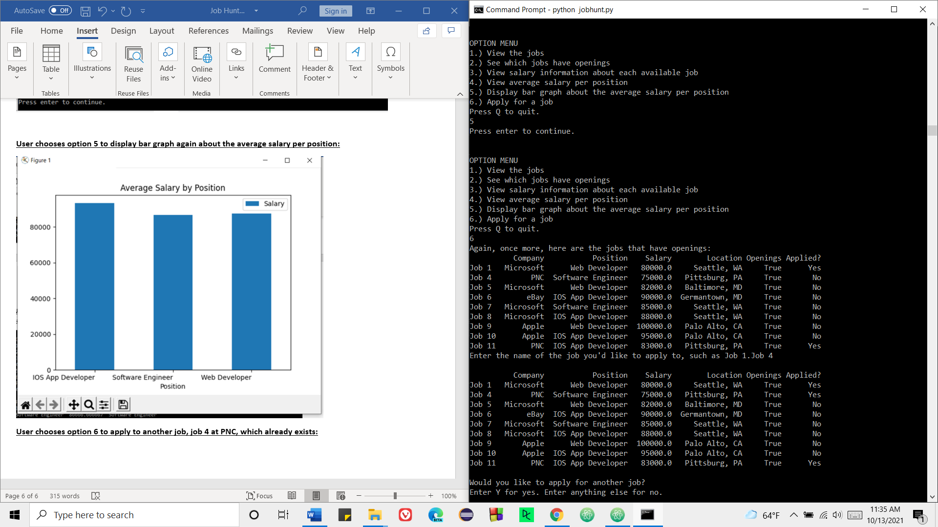

**After the user presses Q to quit/exit the Job Hunt program, they are asked to save their changes/send their job data to a new csv file called updated_jobs_data.csv for later future access:**

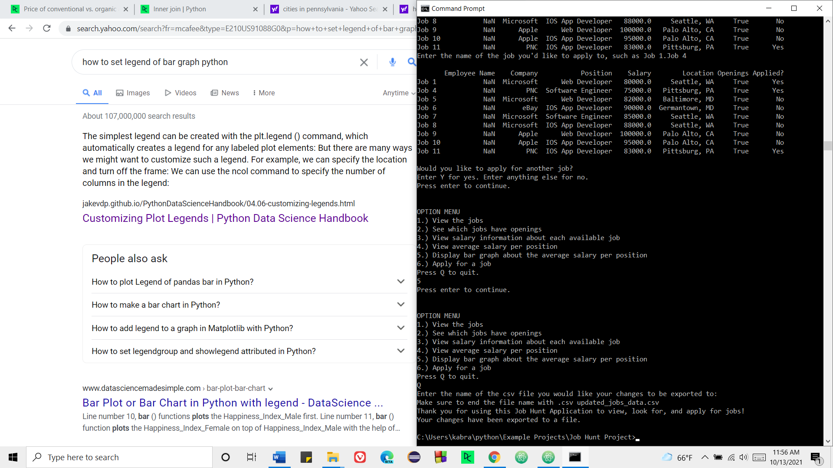

**We see that this file has been in fact created. If we open the updated_jobs_data.csv file, we shall see the respective changes and updates have been made to the job data that we started with. This file can later be accessed and the user can continue to apply for current jobs and new jobs and continue to manipulate, access, and use the job data:**

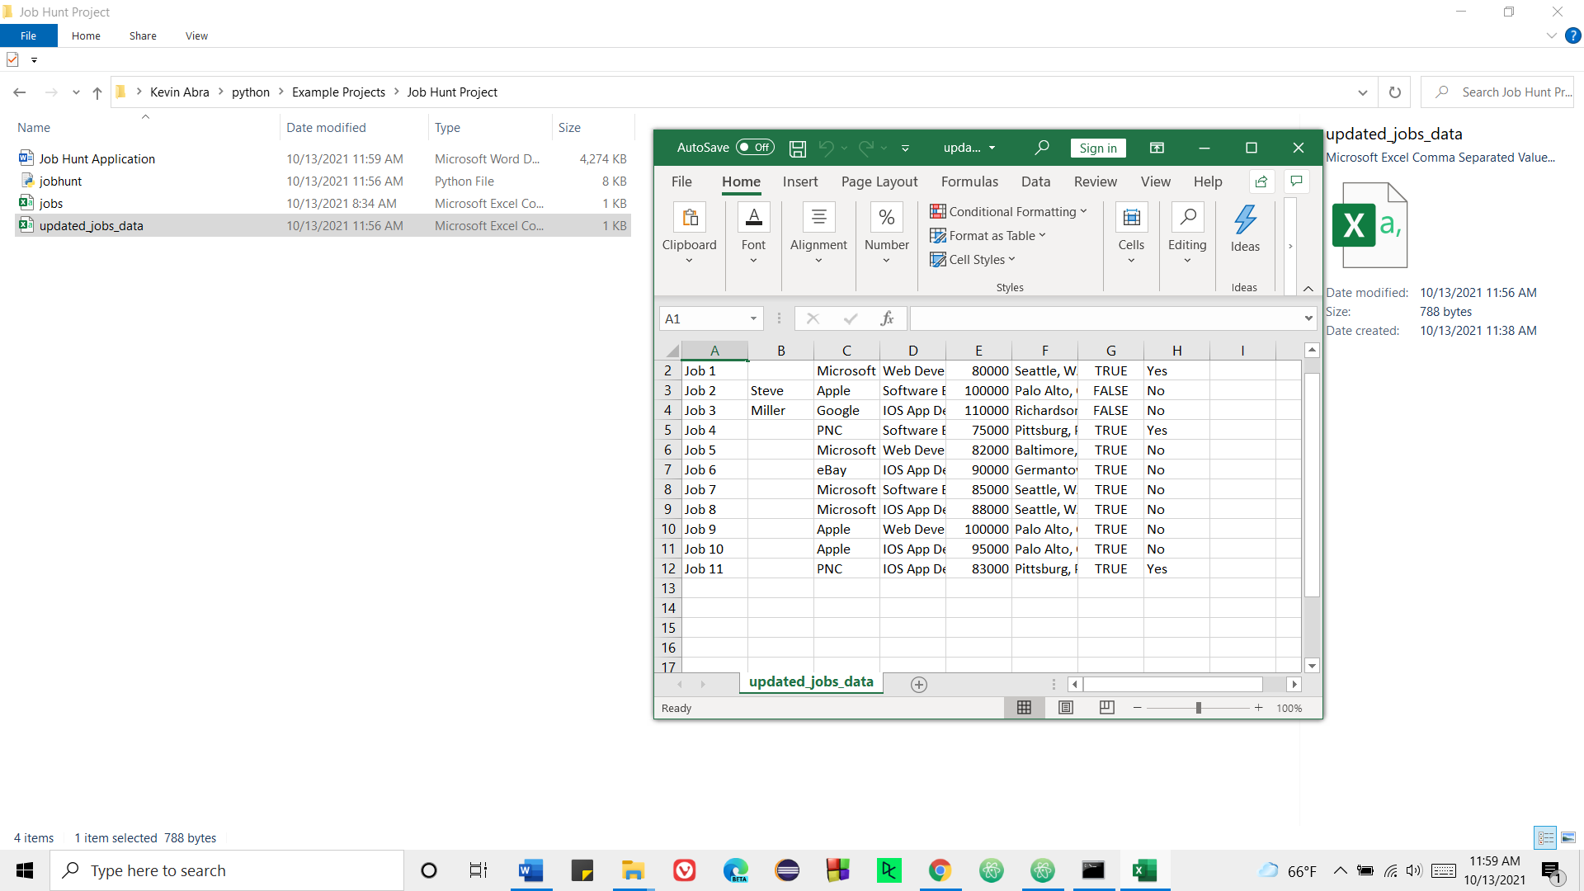

**The user reruns the program and loads this new job data from updated_jobs_data.csv:**

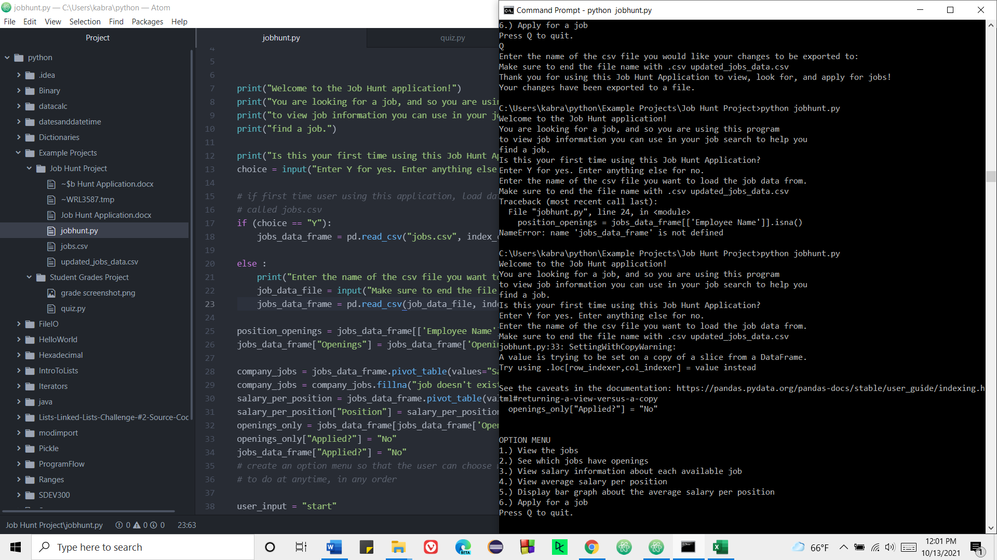

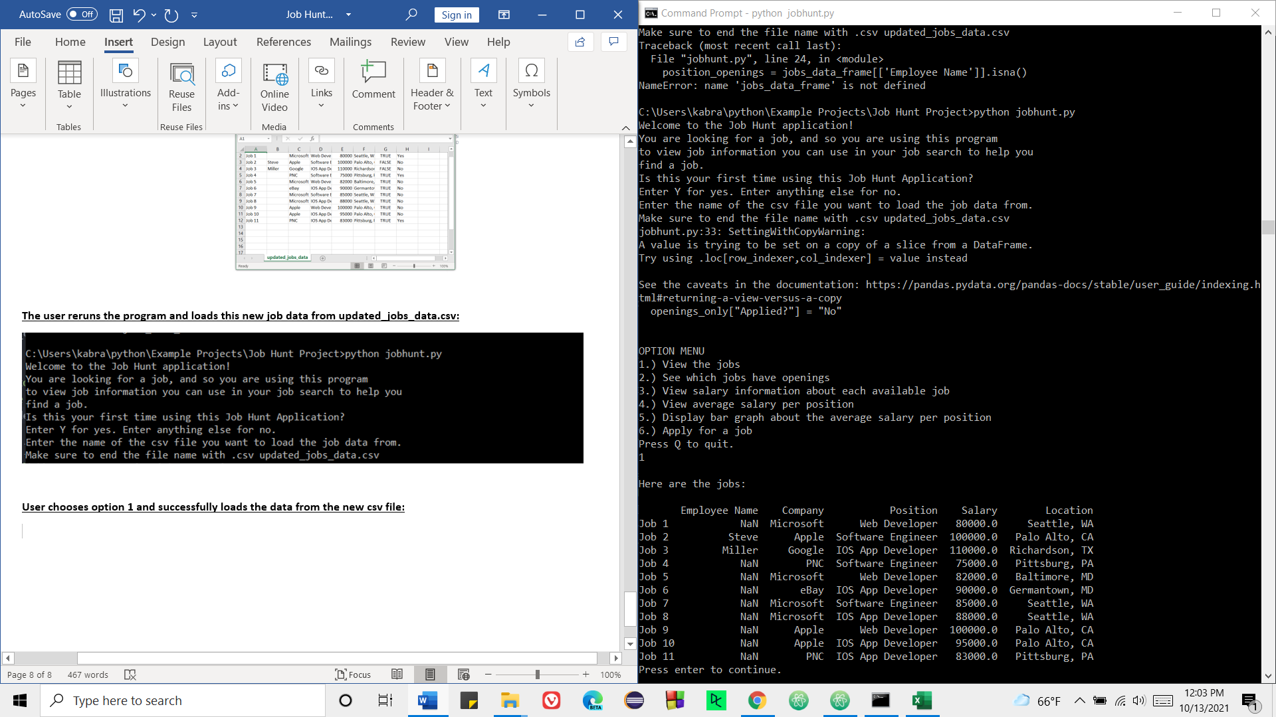**User chooses option 1 and successfully loads the data from the new csv file storing the new job data:**